PRODUCT REQUIREMENT DOCUMENT
BERTH PLANNING AND ALLOCATION OPTIMISATION
Date | Author | Version | Affected Module
29/01/26 | Niraj Kumar | 1.0 | Berthing

Team Member(s)
Name | Role
Dipesh Pansuriya | Team Lead – Developer
Ankur Rai | Developer
Sayandeep Haldar | Developer
Niraj Kumar | Product Manager

Reviewer(s)
Name | Role | Sign Off Date
Shruti Pandit | Mentor – AI/ML

PROBLEM DEFINITION
Ports handle multiple vessel calls each day, with every vessel having unique characteristics such as estimated arrival time, cargo volume, service priority, and berth requirements. Current berth planning practices are often manual or rule-based, making them highly sensitive to delays caused by weather conditions, tidal variations, or operational constraints.
Even minor deviations in vessel arrival times can result in:
- Berth congestion
- Increased vessel waiting and idling time
- Sub-optimal utilization of berth infrastructure
- Reduced port throughput and operational inefficiencies
There is a need for an intelligent, data-driven berth planning system that can accurately predict vessel arrival times and dynamically optimize berth allocation to ensure efficient port operations.

PROBLEM STATEMENT
How can Artificial Intelligence be used to predict vessel arrival times and optimise berth allocation in order to:
- Minimise vessel waiting time at anchorage
- Improve vessel turnaround time (TAT)
- Increase overall port throughput and berth utilisation?
OBJECTIVE OF SMARTBERTH AI
SmartBerth AI is an AI-powered berth planning and allocation system that enables Terminal Operators to:
- Proactively plan berth schedules based on predicted ETAs
- Dynamically re-optimise berth allocation in response to delays and disruptions
- Improve operational efficiency and decision-making through data-driven recommendations
SmartBerth AI – AI Use Cases
- Vessel Arrival & Readiness Intelligence
1.1 Predictive ETA Calculation
AI predicts actual vessel arrival time instead of relying on declared ETA.

Data Points
- Historical arrival/departure data
- AIS movement patterns
- Weather & tidal data
- Port congestion patterns
1.2 Arrival Deviation Detection
AI continuously compares:
Planned ETA vs Predicted ETA vs Actual movement
Use Case
- Early detection of delays (6–24 hrs before arrival)
- Automatic alert to planners

1.3 Vessel Readiness Prediction
AI predicts whether a vessel is berth ready.
Factors
- Pilot/Tug availability
- Tidal window
- Previous port departure delays
- Regulatory clearance readiness (high-level)
- Berth Allocation, Dynamic Re-Planning
2.1 Constraint-Based Berth Allocation
AI matches vessels to berths using operational constraints:
Constraints
- Vessel LOA / beam / draft
- Cargo type compatibility
- Berth equipment availability
- Tidal restrictions
2.2 Real-Time Re-Optimisation
When delays occur, AI:
- Re-calculates berth schedules
- Minimizes cascading impact on other vessels
2.3 Conflict Detection & Resolution
AI detects:
- Berth overlaps
- Resource clashes
- Tidal window conflicts
Then auto-suggests resolutions, not just alerts.

- What-If Simulation & Decision Support
3.1 Delay Impact
Planner asks:
“What happens if Vessel AAA arrives 8 hours late?”
AI simulates:
- Impact on waiting times
- Berth utilisation
- Downstream vessel delays
3.2 Capacity Management
AI simulates:
- Surge in arrivals
- Berth closure (maintenance)
- Weather disruption scenarios

USERS & PERSONAS
Primary User(s)
Terminal Operator(s)
- Responsible for berth scheduling and vessel sequencing
- Needs advance visibility and quick re-planning during disruptions
Secondary User(s)
- Port Operator(s) – monitors throughput & KPIs

SmartBerth AI – UML, ERD, RAG Mapping Diagrams
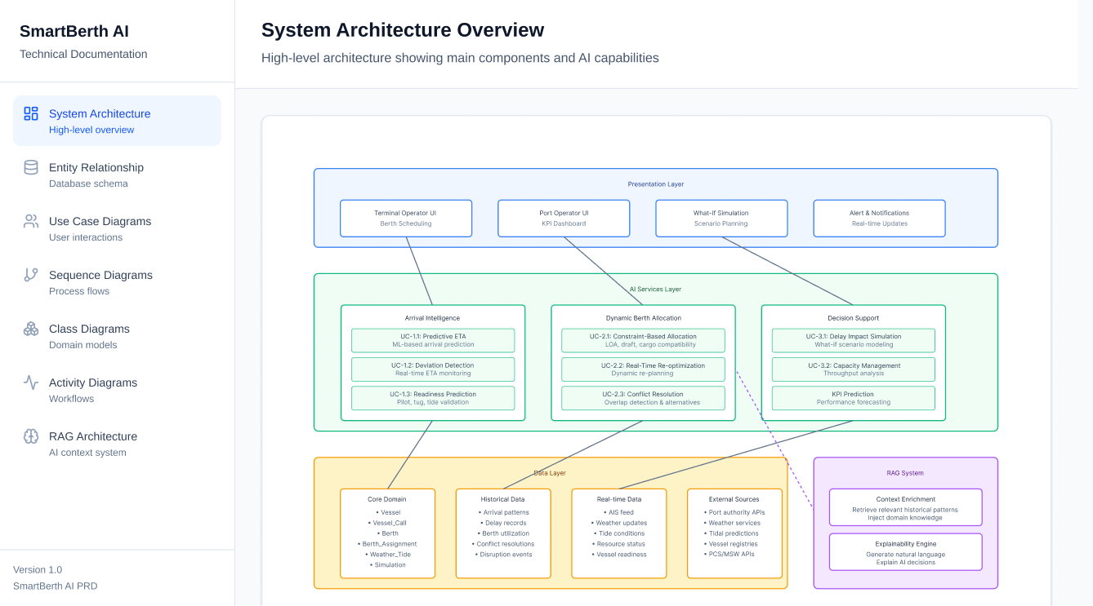
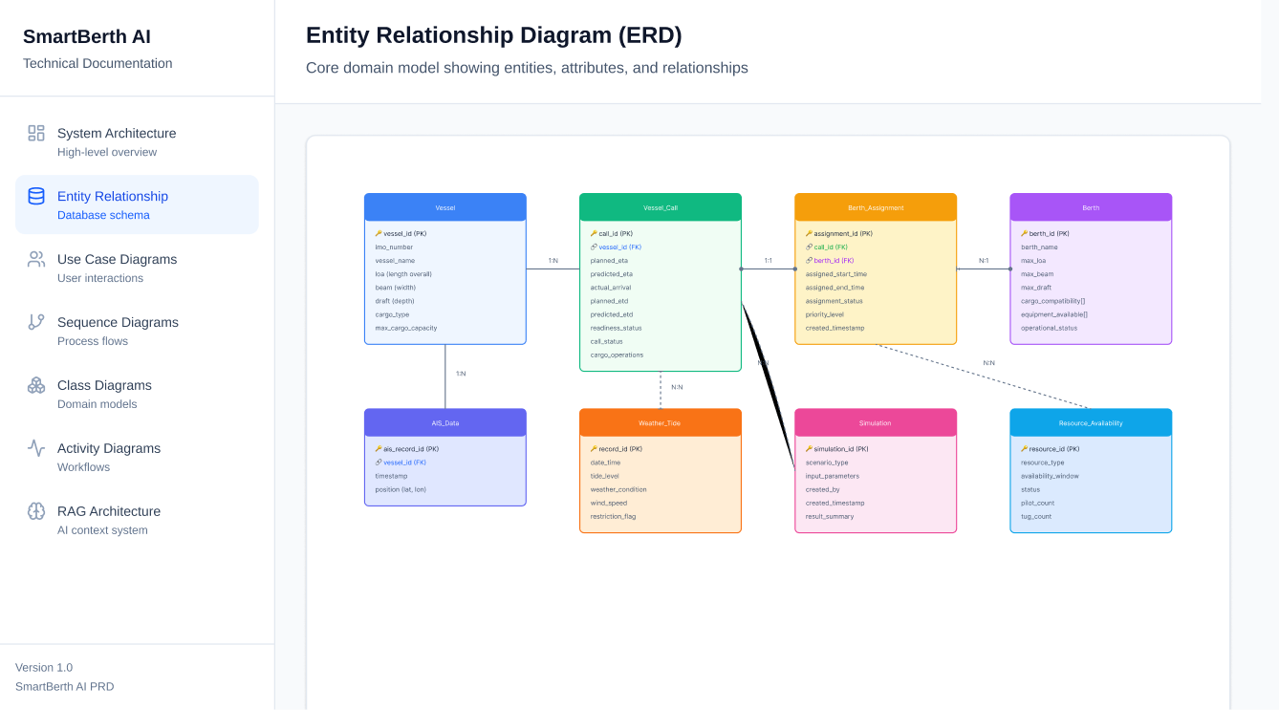
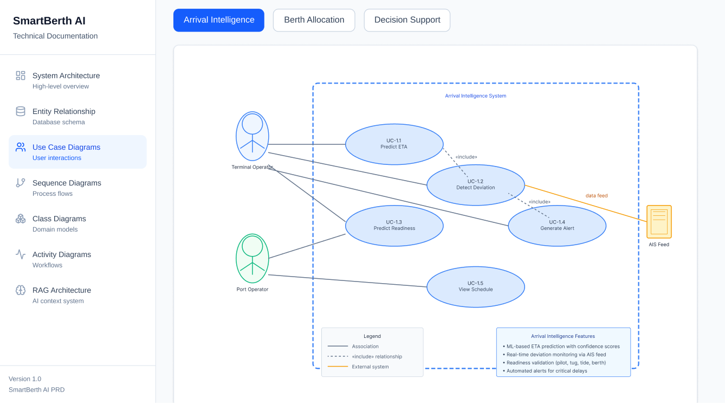
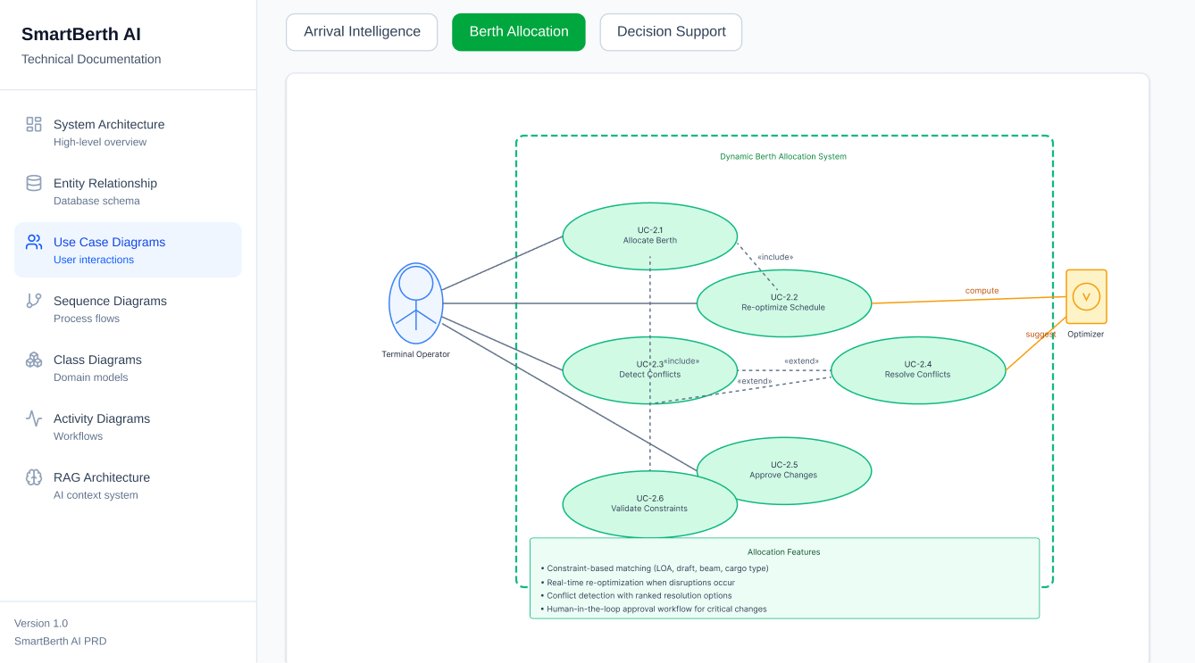
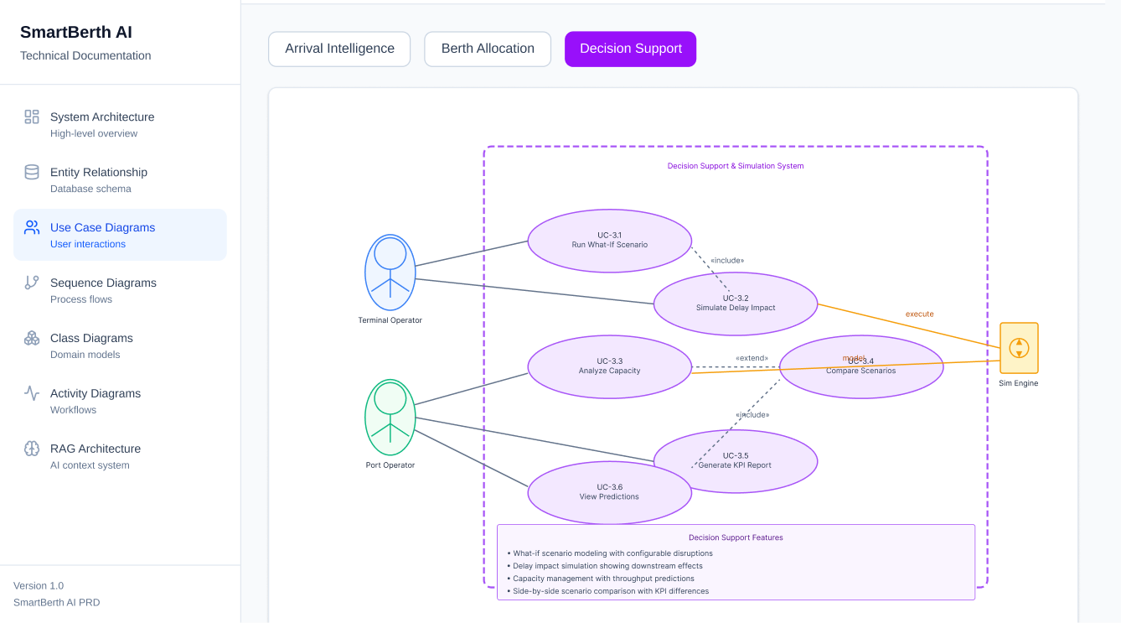
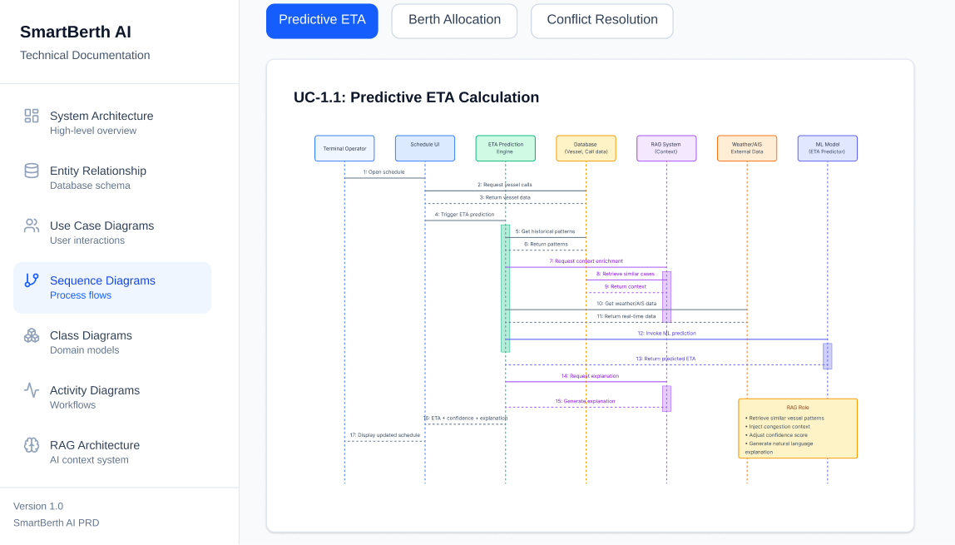
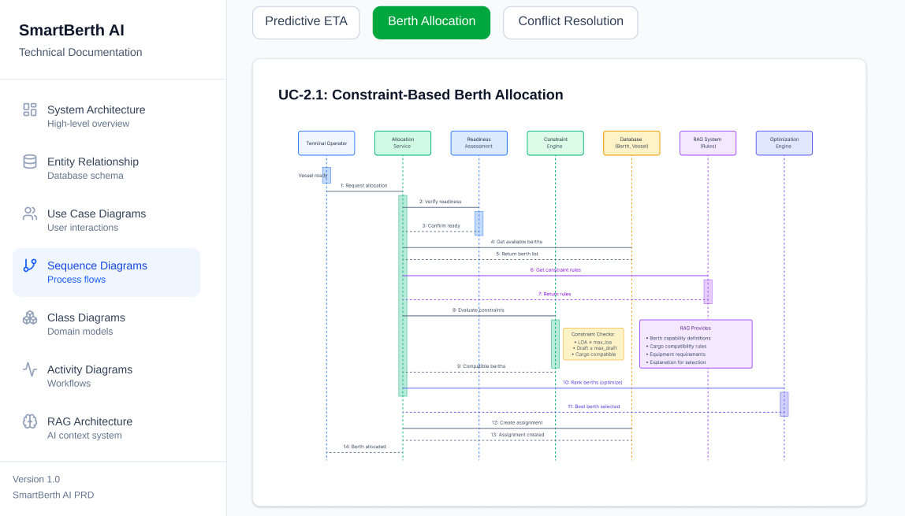
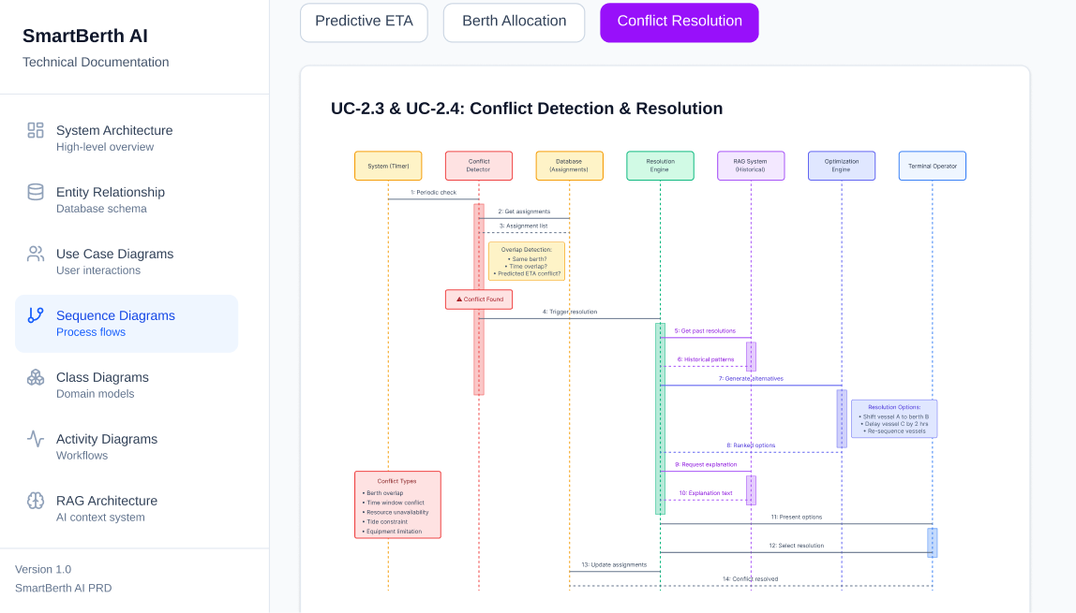
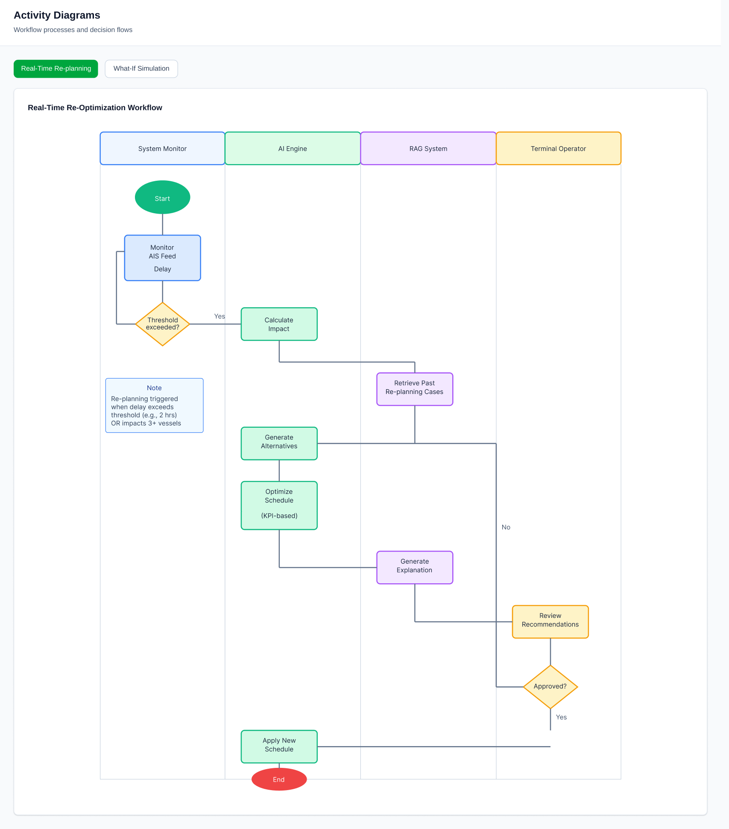

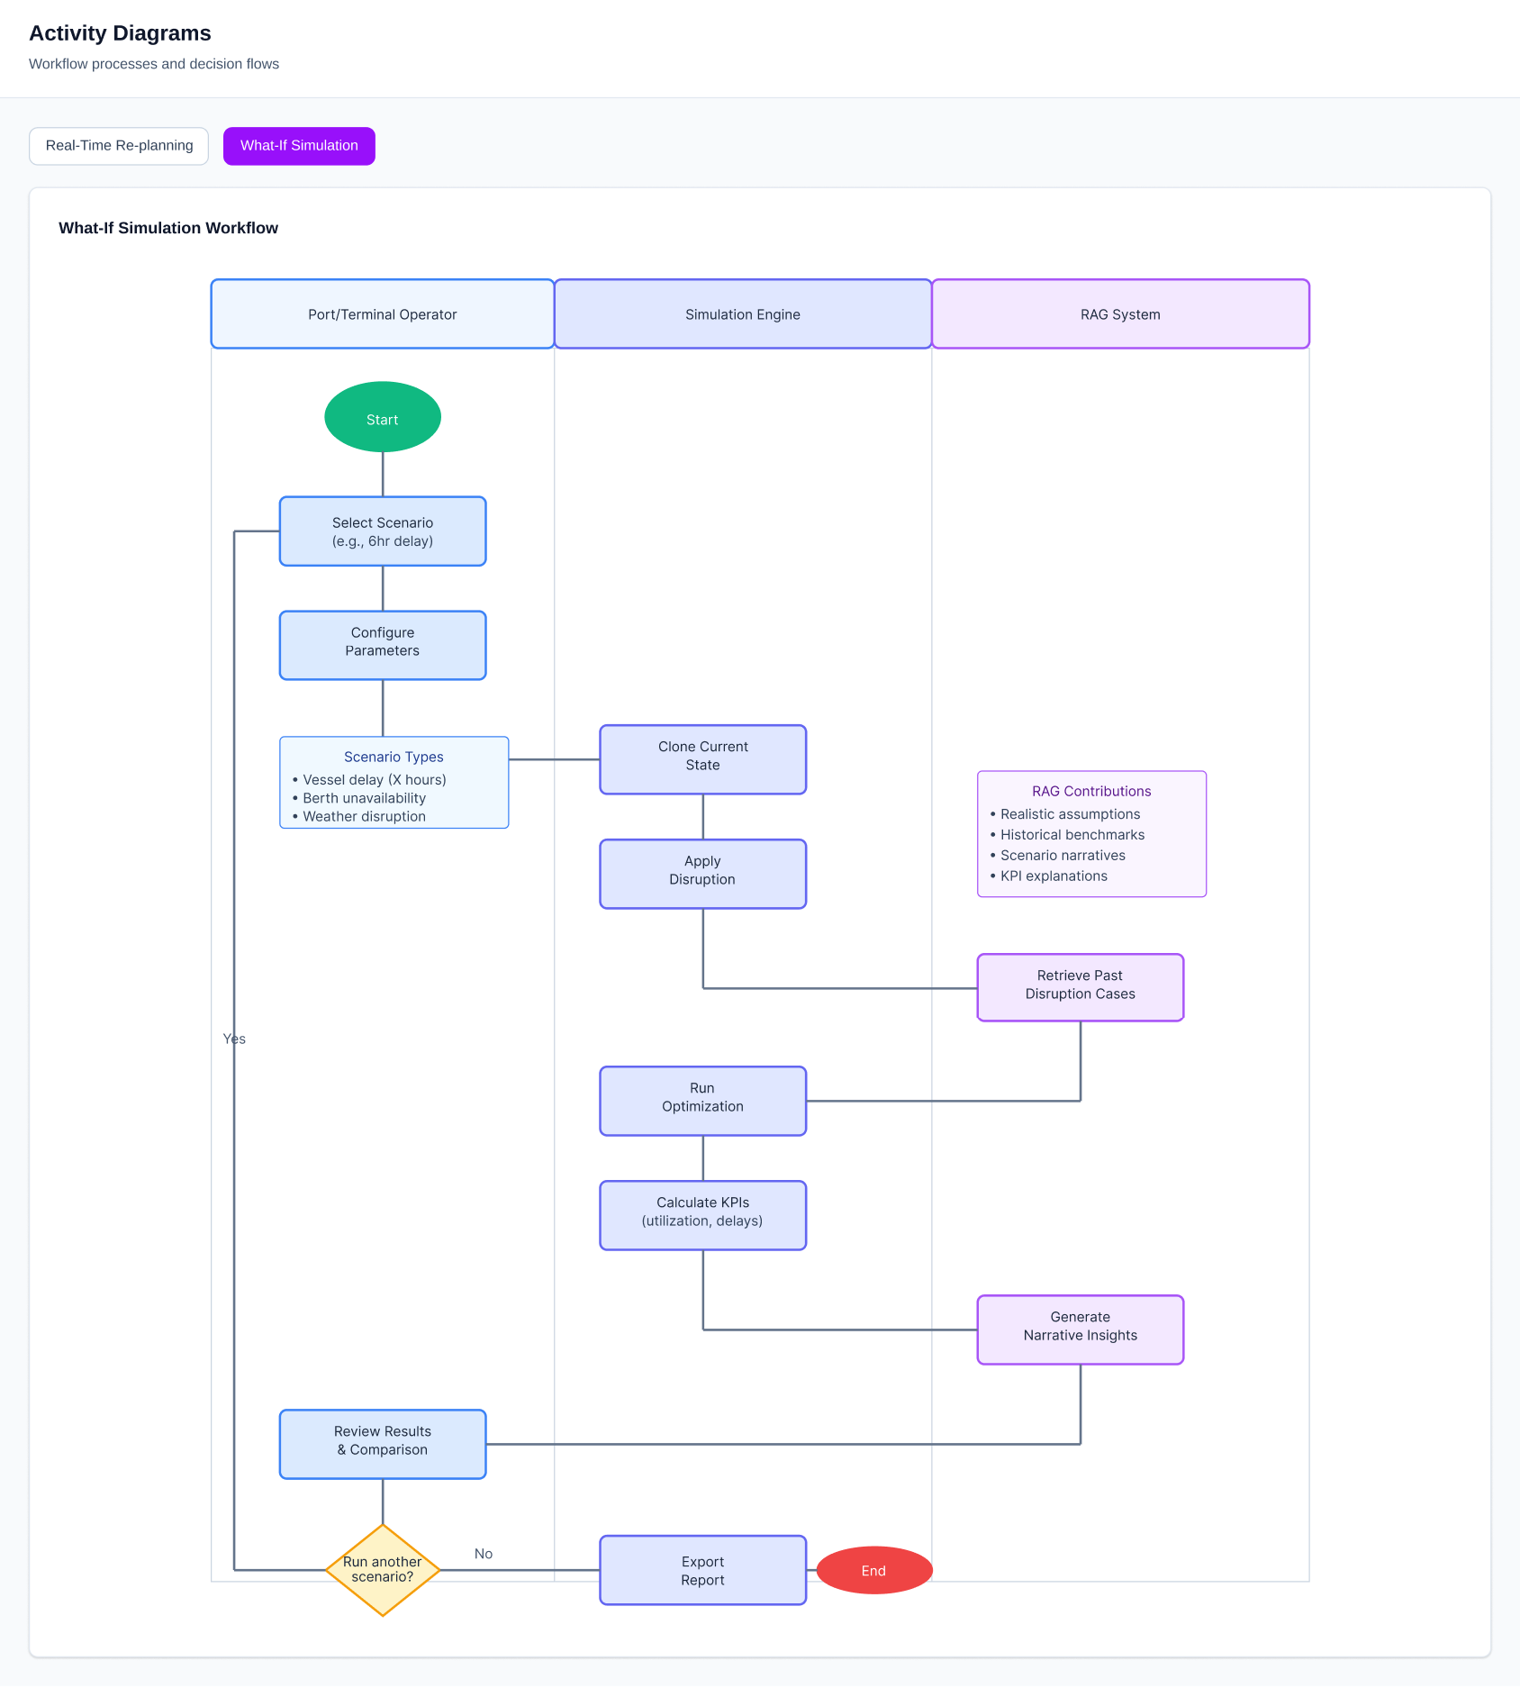
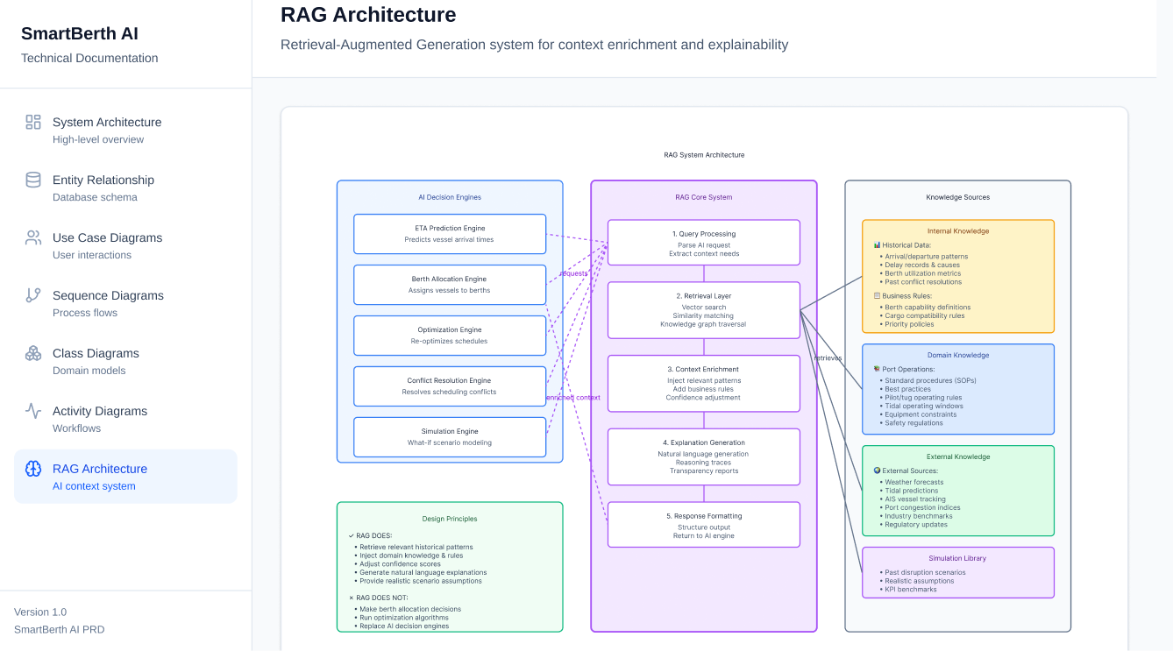

FUNCTIONAL REQUIREMENTS – WIP

